Assignment 3

Task: Develop a weather data API using Flask and MongoDB for storing and retrieving weather data.

1. Implemented authentication Mechanism using Flask.

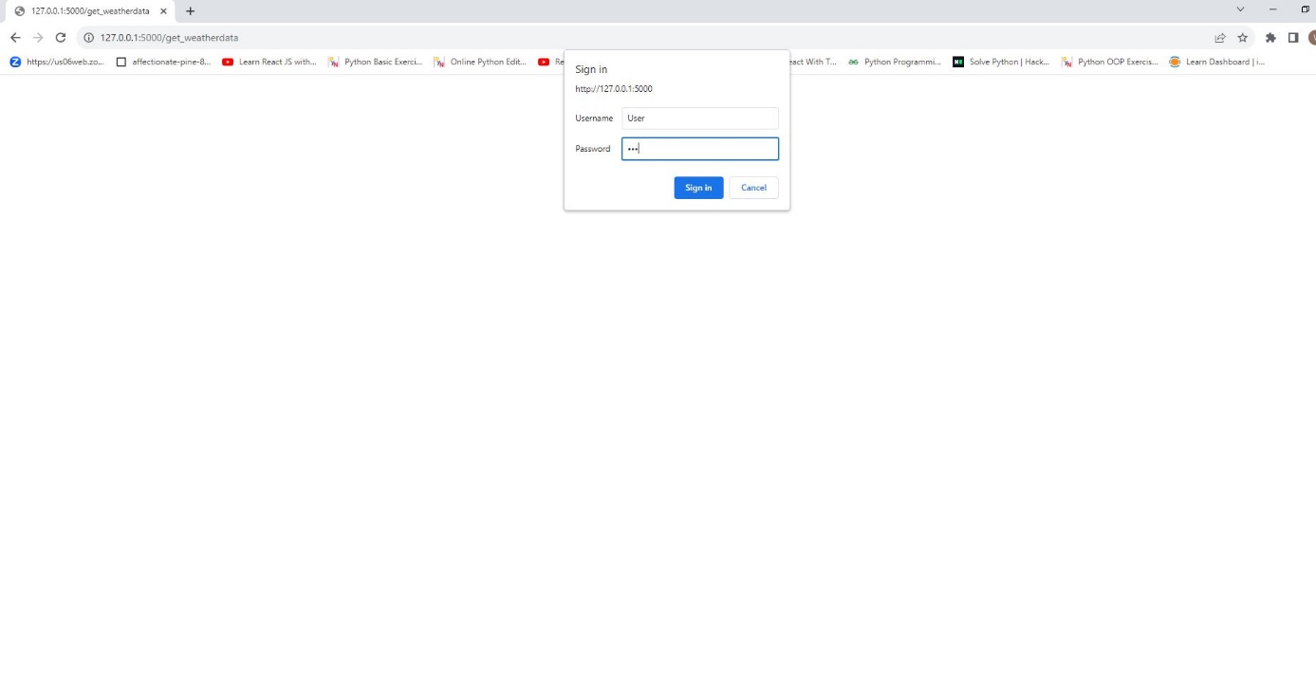

2.Built a REST API using the Flask framework that exposed endpoints for retrieving weather data by location.

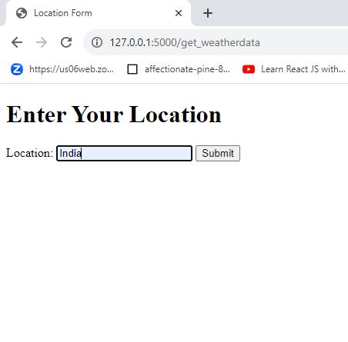

3.After submitting the Location the API retrieve the weather data as below .

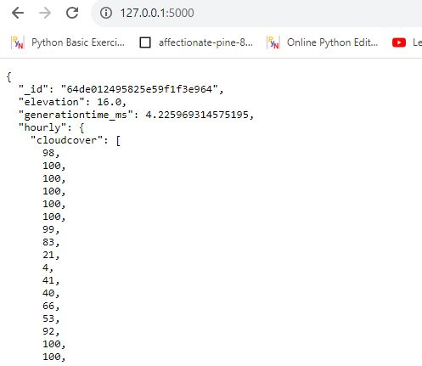

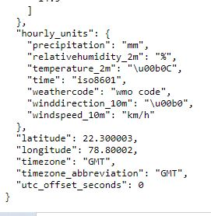

4. Stored the data in MongoDB

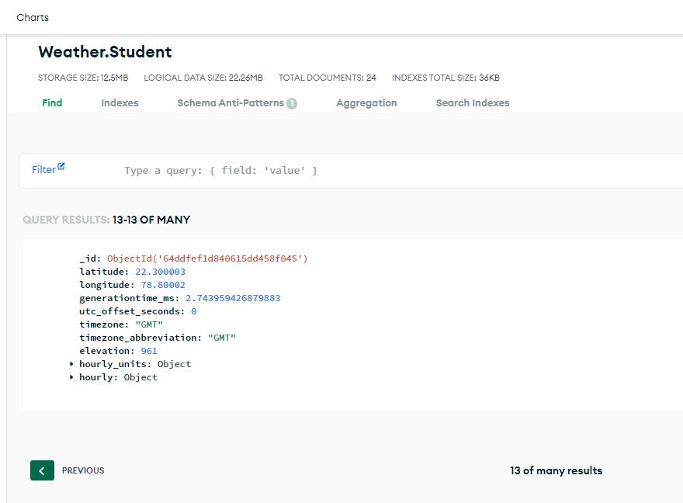

5. Performed CRUD operation for Weather Data

a. Added custom weather condition based on the location in MongoDB

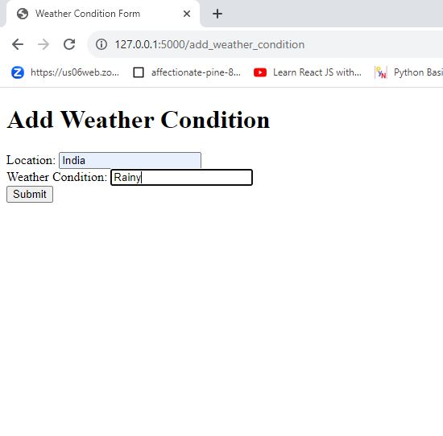

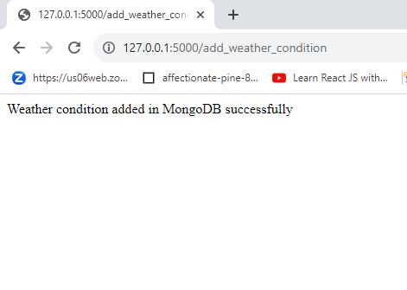

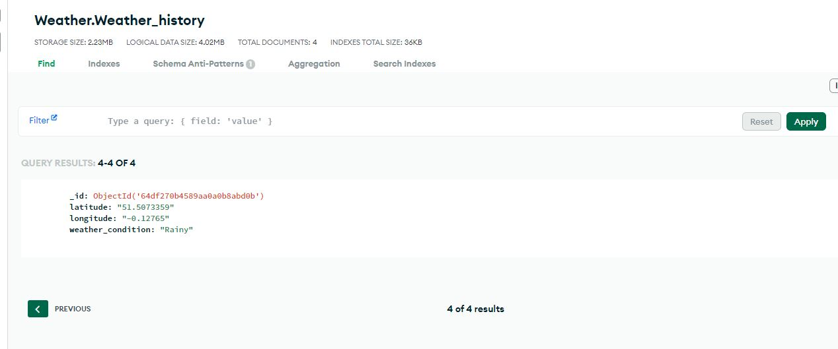

b. Removed weather data from the Mongo DB

